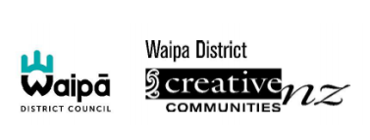
Creative Communities Scheme April 2021
Successful applicants
Applicants Name | Project | For more information
Te Wahrekura o Nga Purapura o Te Aroha | Waipā Kapa Haka Festival | Contact: jade.tapine@npota.school.nz
IA Music | Whetu - Live Music Art Film | https://www.facebook.com/IAMAORIMUSIC
Oriwa Morgan Ward | Matariki Holiday Programme | https://tamuseum.org.nz/exhibition/matariki-workshops-2021/
Oriwa Morgan Ward | Wairua Winter Wellness Workshops | https://tamuseum.org.nz/whats-on/
Te Awamutu Competition Society of Performing Arts | A festival for participants to compete in their chosen field | http://www.teawamutucompetitionssociety.com/
St Peter’s Catholic School | School Production | https://www.stpeterscatholic.school.nz/
Ngaa Poutiaki & Cambridge High School | Kapa Haka Festival | http://www.camhigh.school.nz/
Mosaic Waikato Modern Choir | Choir Performance | http://www.mosaicchoir.com/
ConneXu | Creative ball | https://www.connexu.nz/
Cambridge Society of Arts | Painting workshop | https://www.facebook.com/cambridgeartsociety/
Ohaupo Playcentre | Our Pepeha | https://www.facebook.com/OhaupoPlaycentre/

