Permitted Sites: Mobile Trading
________________________________________________________________________

The following are permitted sites for mobile trading within Waipā District.

Permitted sites are areas that mobile traders should be located in, in the first instance.
However, we do not allow two competing traders to operate from the same site at the same time.

Where a trader wishes to locate in areas outside of the permitted areas, Council will assess the application based on criteria listed on Council’s webpage.

Victoria Street – opposite the Town Hall, Cambridge
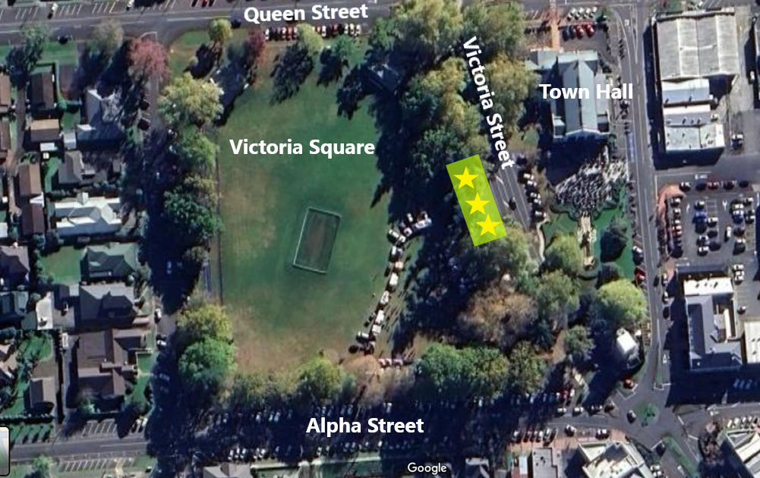
Maximum traders at any one time: 3
- The towing vehicle for the mobile truck must be parked off site when operating from Victoria Street to allow more space for other traders.
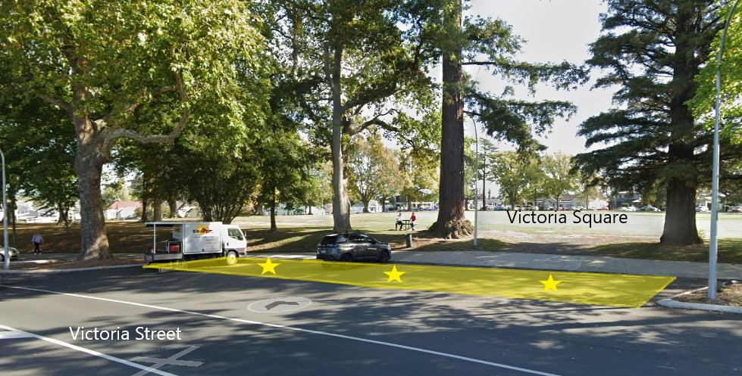
Laurent Road – layby near intersection of Taylor Street, Cambridge
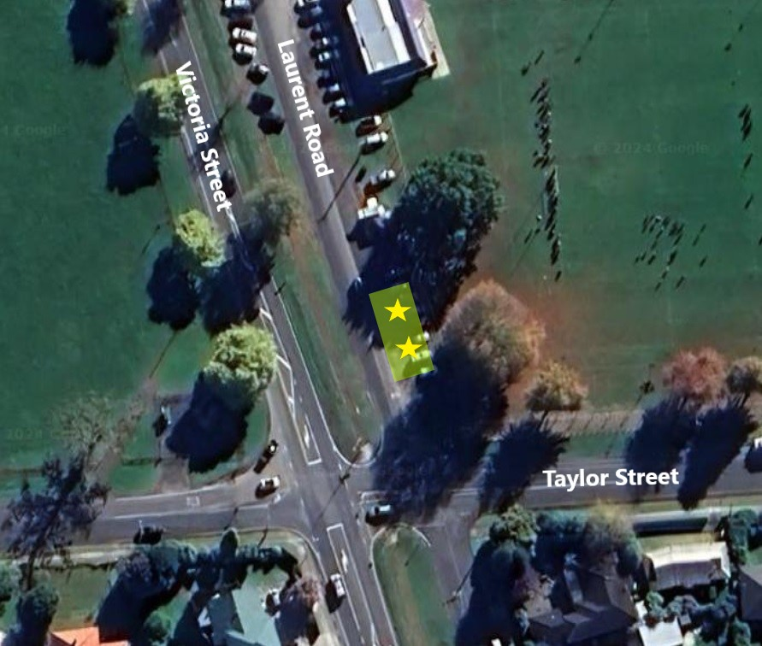
Maximum traders at any one time: 2
- Vehicle and trailer must be parked on the grass area provided no damage to grass or trees is created.

Pope Terrace – layby between Bracken St and Pengover Ave, Cambridge
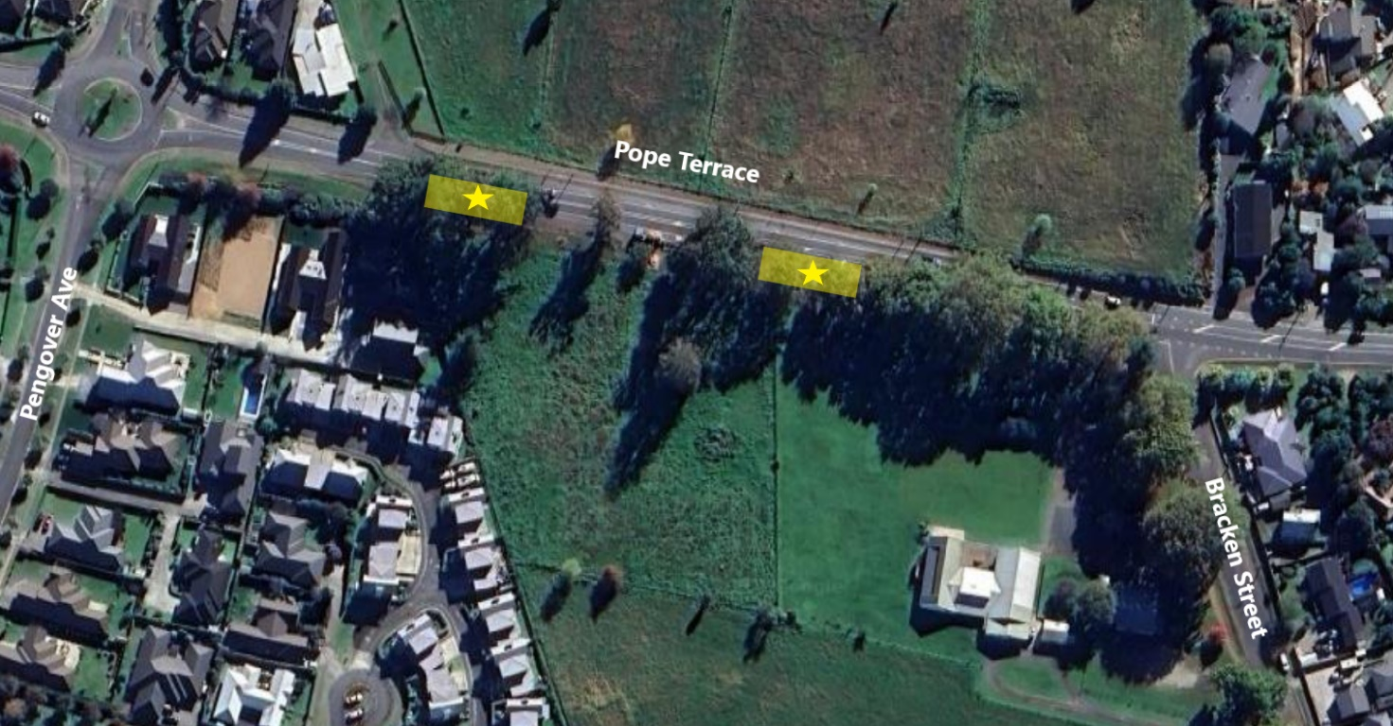
Maximum traders at any one time: 2

- Customers will need to be able to access the service window of the vehicle from the footpath/reserve area behind the bollards. No trading on the shoulder or carriageway is allowed.

- Vehicle and trailer must be parked on the grass area provided no damage to grass or trees is created.

Mutu Street – opposite Memorial Park, Te Awamutu
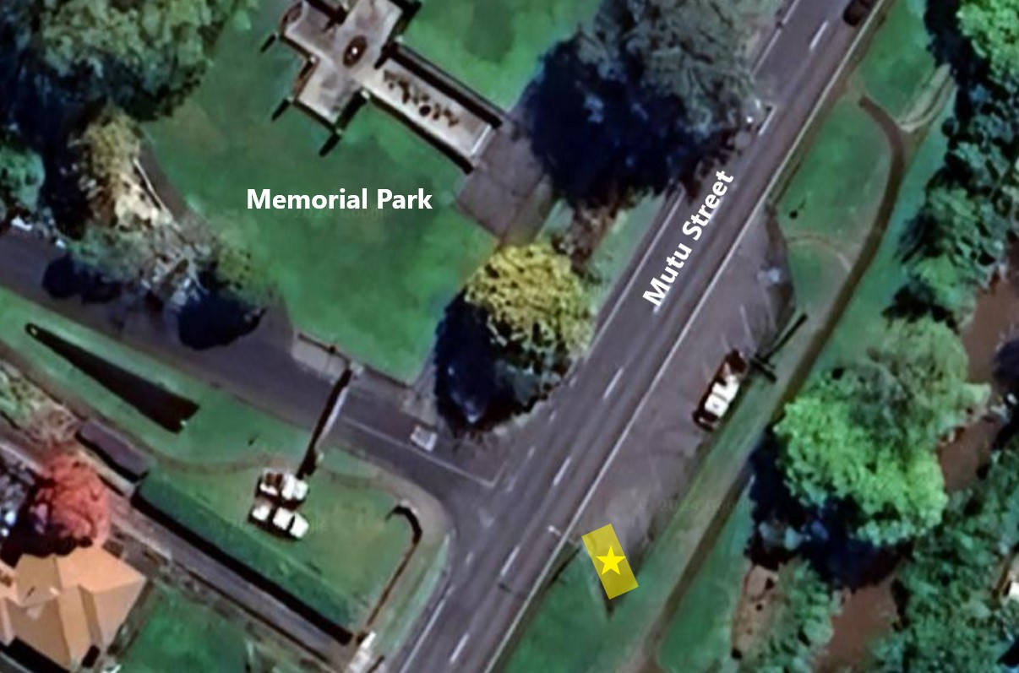
Maximum traders at any one time: 1
- The car park cannot be booked for purpose of trading. The availability will be subject to demand for parking by the public.

- Customers will need to be able to access the service window of the vehicle from the grass area. No trading on the carpark is allowed.

Lyon Street – layby near Leslie Street, Kihikihi
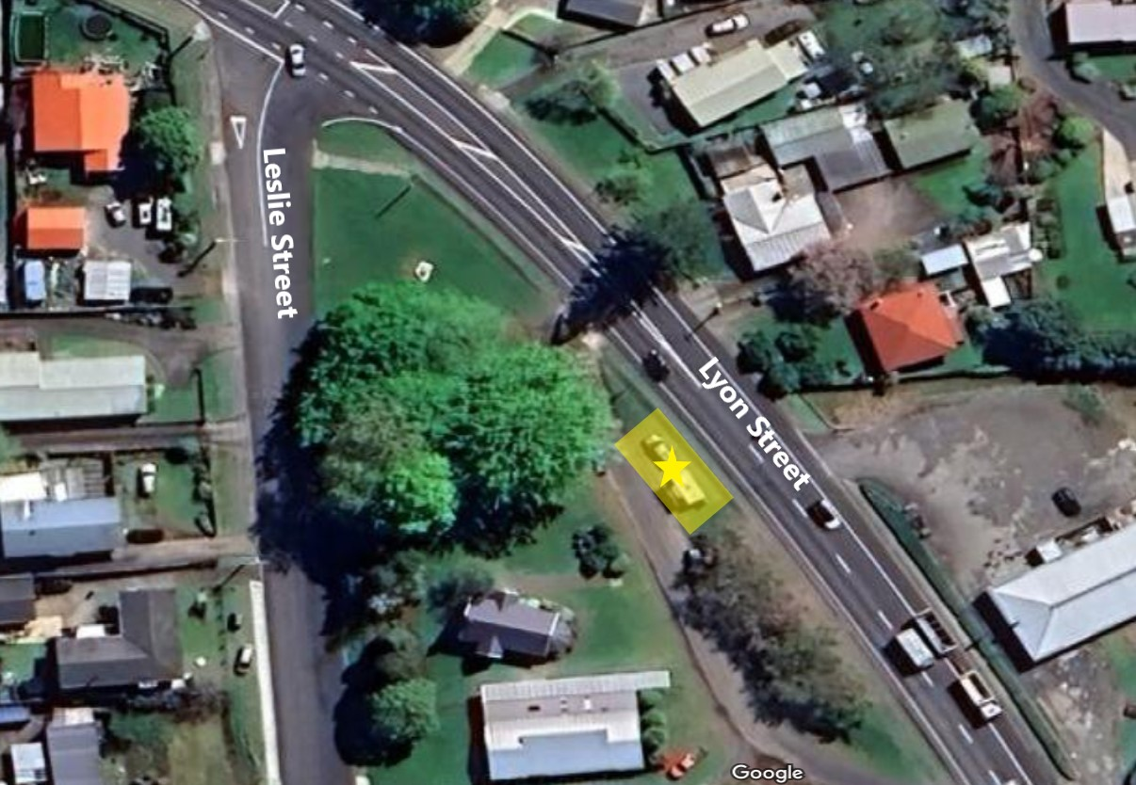
Maximum traders at any one time: 1
- Vehicle and trailer must be parked on the grass area provided no damage to grass or trees is created.

